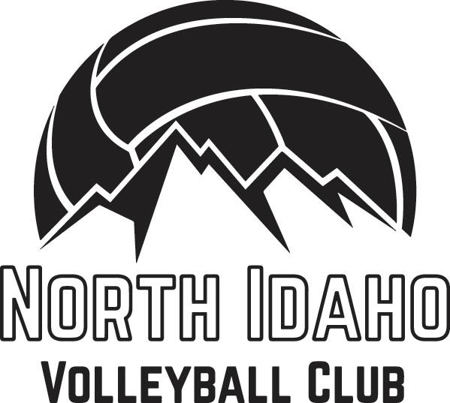

October/ November 2021

Hello Community Member,

First, a big thank you for your consideration!
We are grateful that you are open to supporting our North Idaho Volleyball Club as a local business/entrepreneur.
Since our non-profit organization relies heavily on sponsorship and donors, we are asking local businesses and community members, like yourselves, who love outdoor recreation and/or enjoy supporting locally to do so for our North Idaho Volleyball Club. These funds are necessary in easing the athlete’s dues/fees and allowing our interested youth to become a part of a team and something bigger than themselves. Afterall, North Idaho Volleyball Club is committed to the goal that no deserving athlete will be prevented from being in the club for lack of funds.
Our club has been in a season of inactivity due to youth outgrowing the teams and parents moving on to their new and wonderful lives as their children leave the nests or move onto other interests. So it is not surprising to share that our club fundraising and funds have been lacking and therefore we have been unable to provide much needed scholarships for our applicants seeking financial assistance. We hope that you can help in this feat while our fresh and developing teams gather more through our other fundraising events and bring life back to our local club.
Again, thank you for your consideration in being a sponsor or donor and we look forward to hearing back from you! You can reach our Fundraising Committee organizer, Amanda Davis(Team Parent) at (208) 264-8714 or our Board President, Julia Klontz, at (208) 290-4510 for details on how to donate or sponsor.
Gratefully,
NIVBC Fundraising Committee (Team Parents & Board Members)

IDEAS ON WAYS TO CONTRIBUTE

Make giving fun!
Donate a set amount. Consider a monthly or yearly donation! Pay by cash, check or Venmo(username @NorthIdahoVolleyballClub)
Sponsor individuals by covering their membership dues and registration fees
Other ways to sponsor that will benefit you:
- Sponsor our uniform and accessory swag that shows your logo (Contact Rebecca @208-6273888 for a quote)
- In-Kind Sponsorship: Purchase a list of supplies for a fundraising event - Provide us with your company banners and business swag and we advertise for you!
- Provide a venue or catering for the club to conduct fundraising or to celebrate team victories.
- Sponsor a club coupon book that supports local business including yours!

